***CVAT Documentation***

CVAT is an interactive video and image annotation tool for computer vision. We can use it online as well as offline.

Download CVAT on localhost by provided link:

<https://opencv.github.io/cvat/docs/administration/basics/installation/>

When completing with all the steps of downloading with above link just open chrome and type: localhost:8080 you get the CVAT interface.

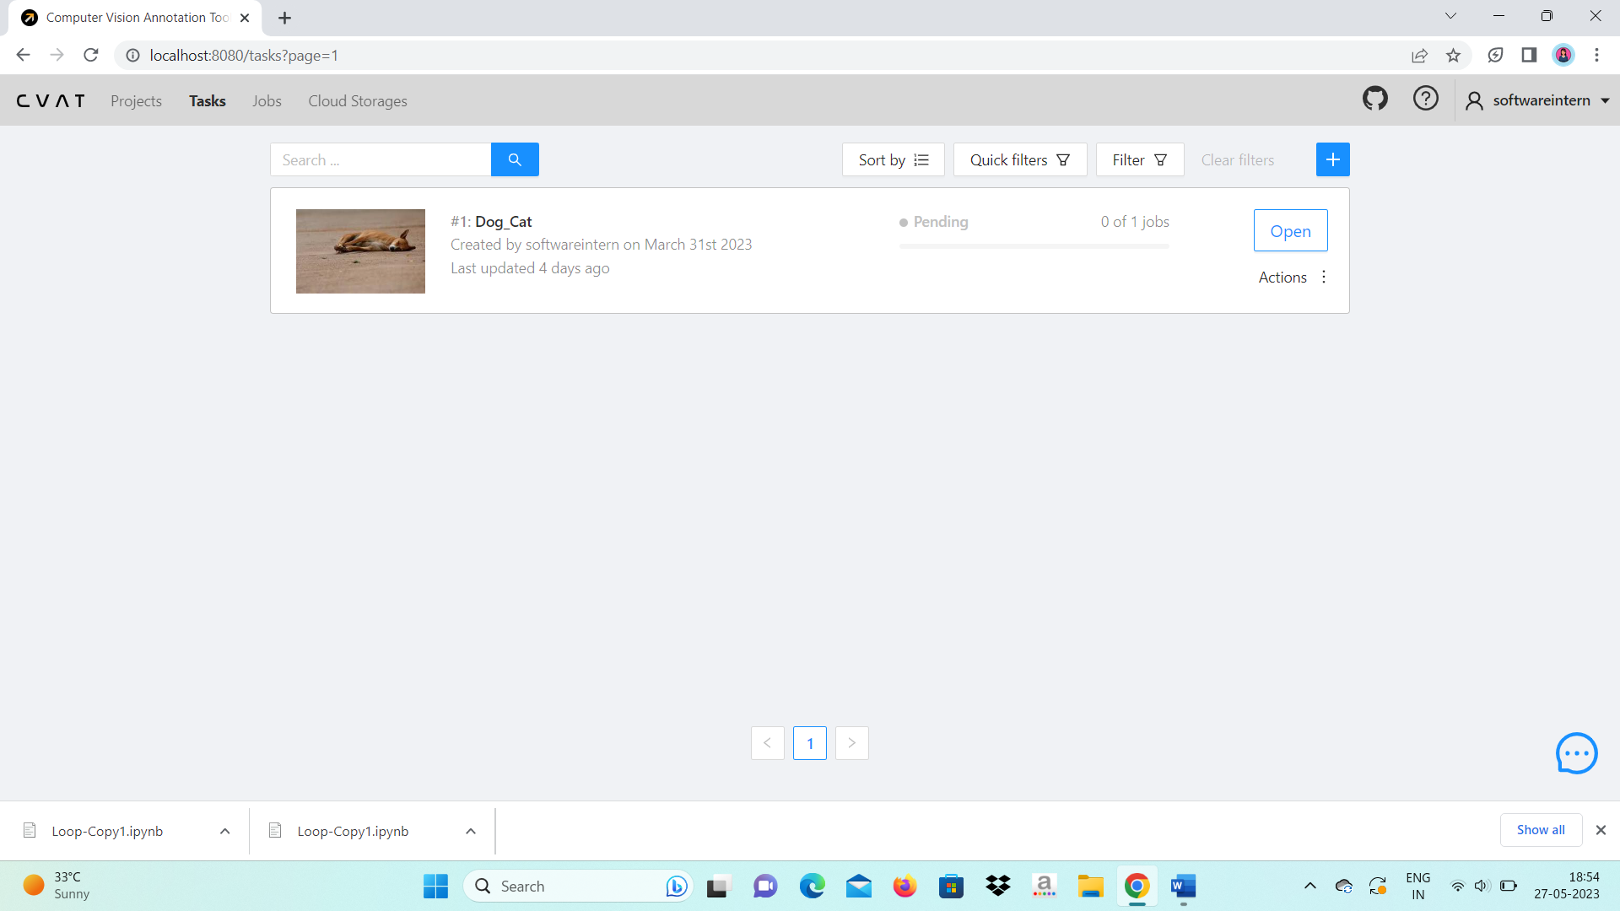

In projects we can create multiple projects it would work like a directory to store our multiple tasks.

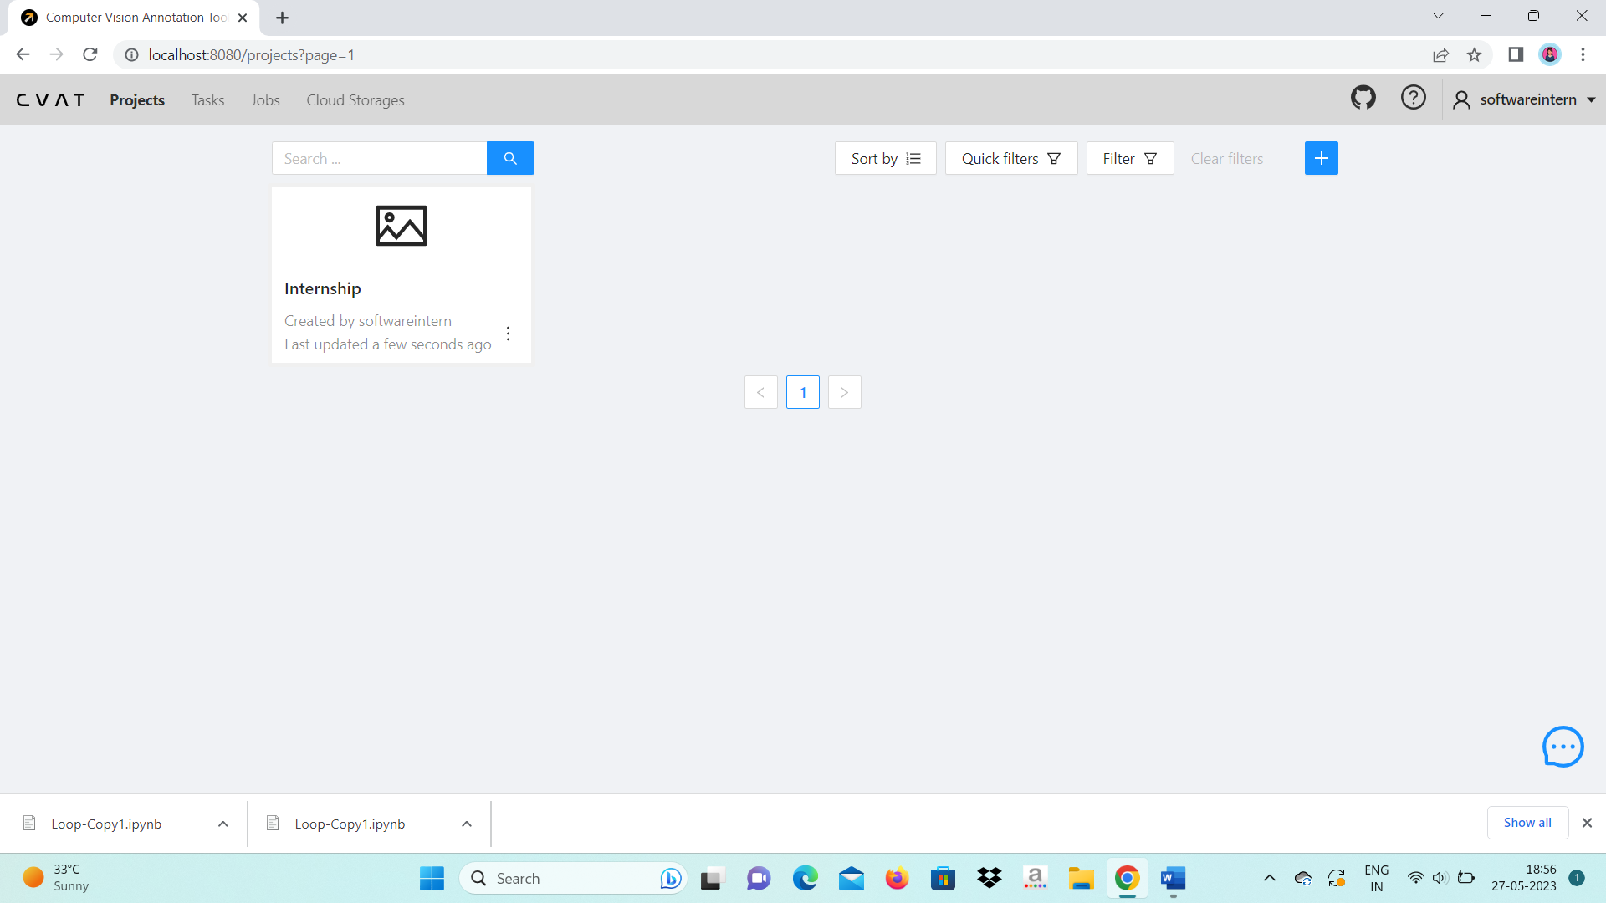

In projects you can create new task or add with our local machine storage. You can create multi-task too. Add labels and submit.

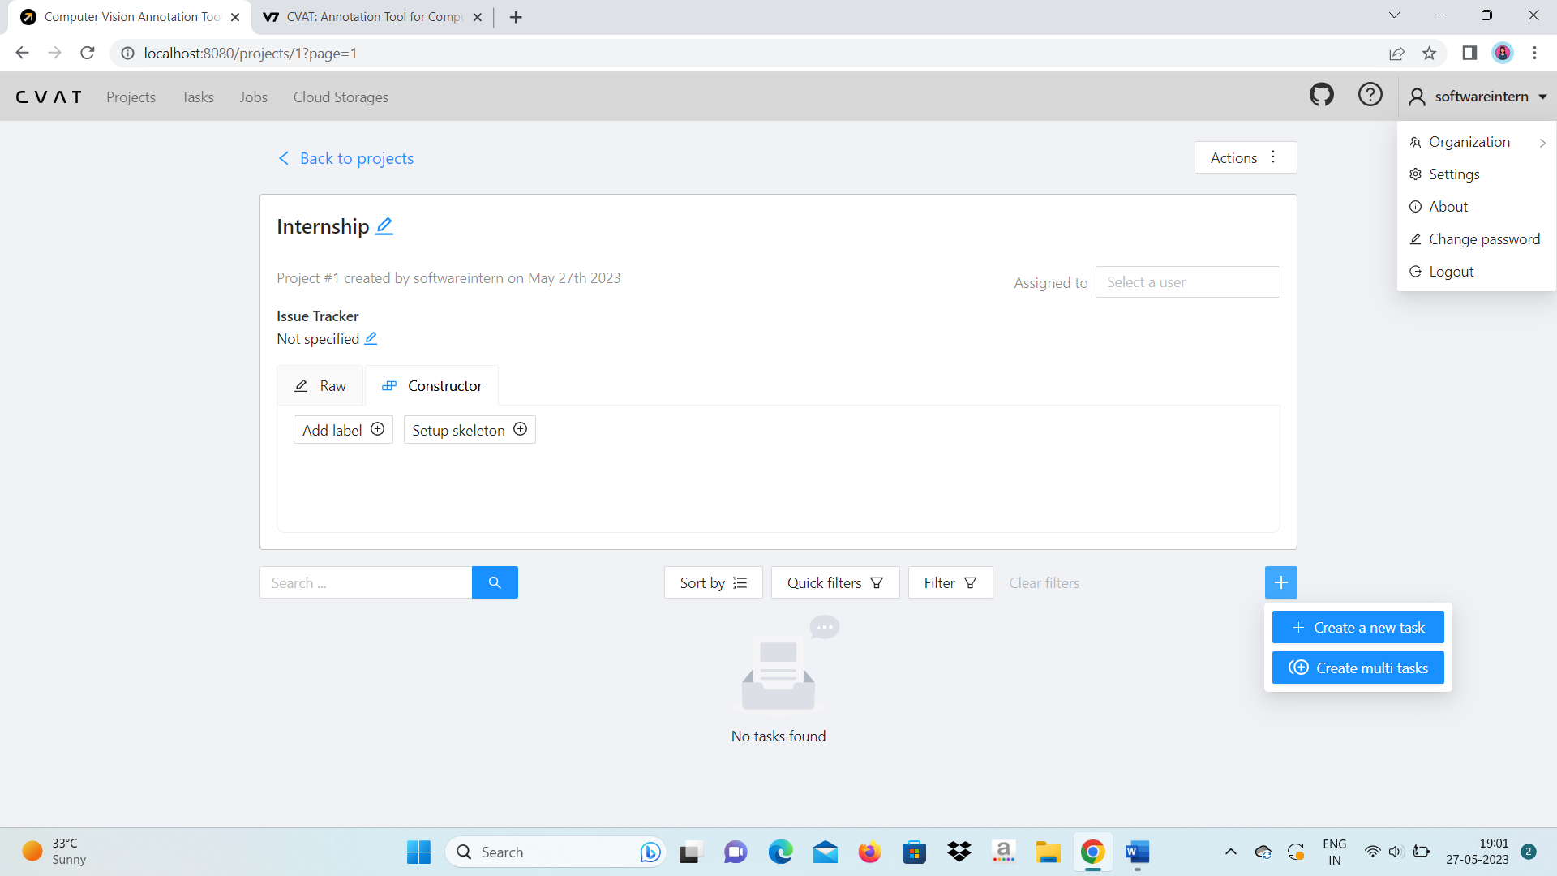

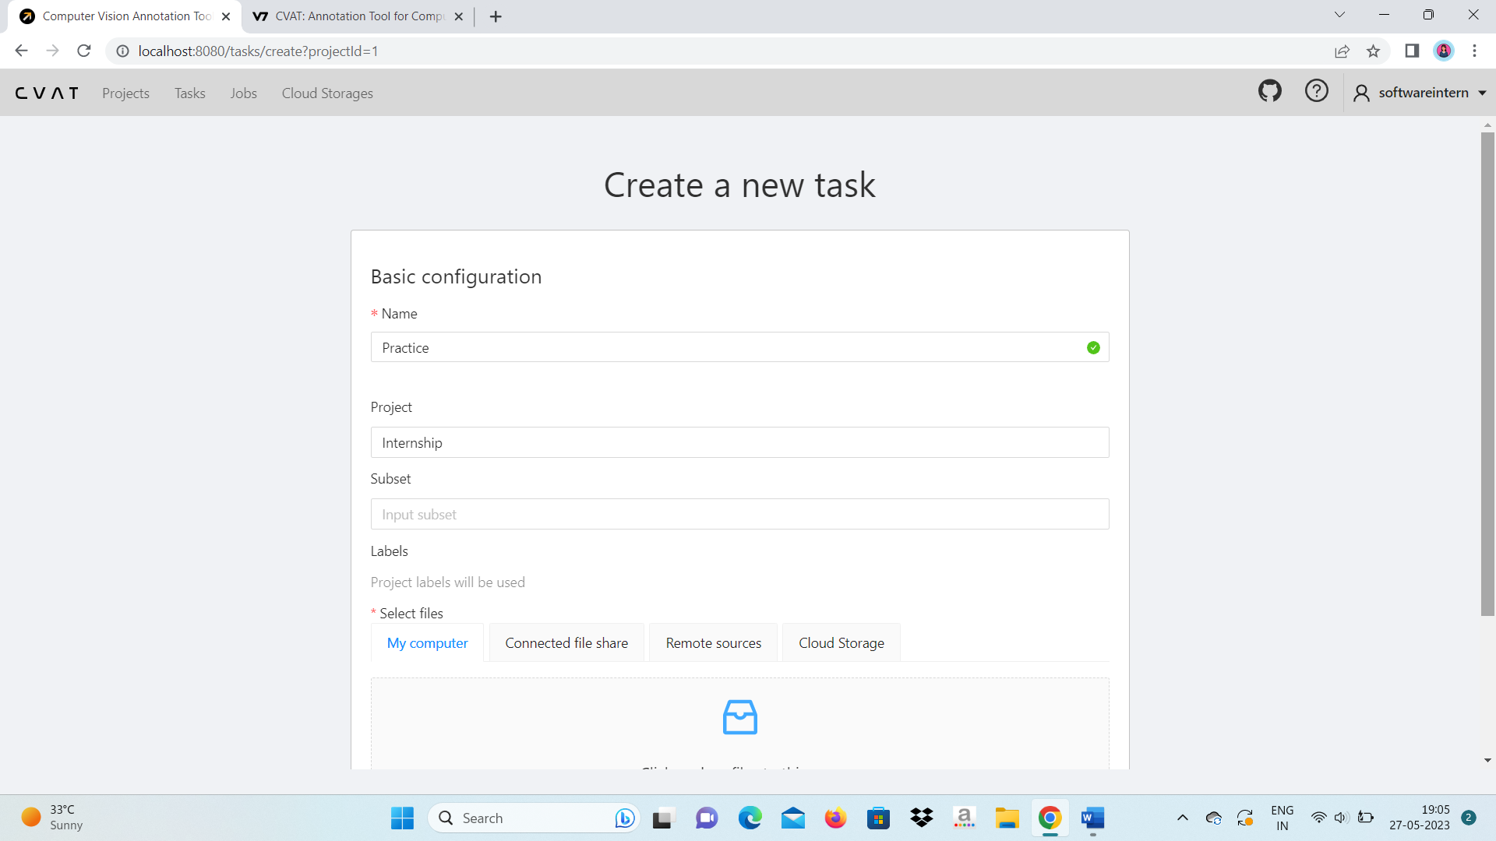

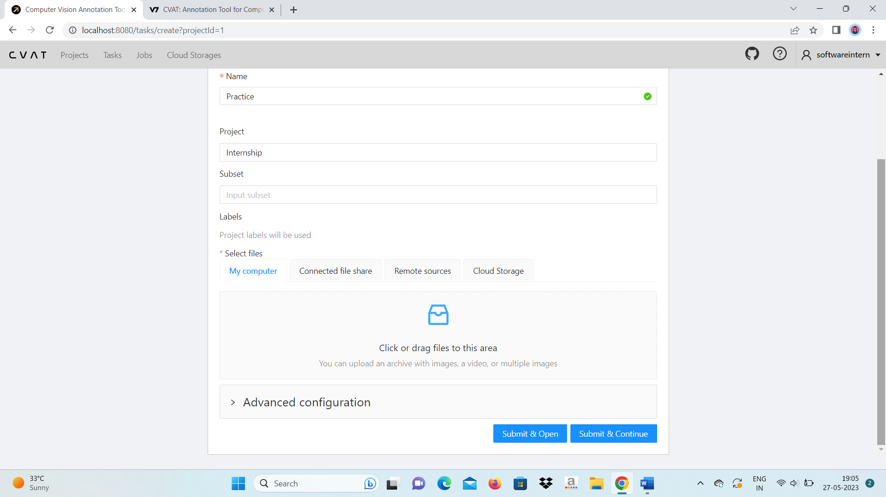

We can create task directly without going to project tab. Click on + sign and upload images or videos that want to annotate and click on open.

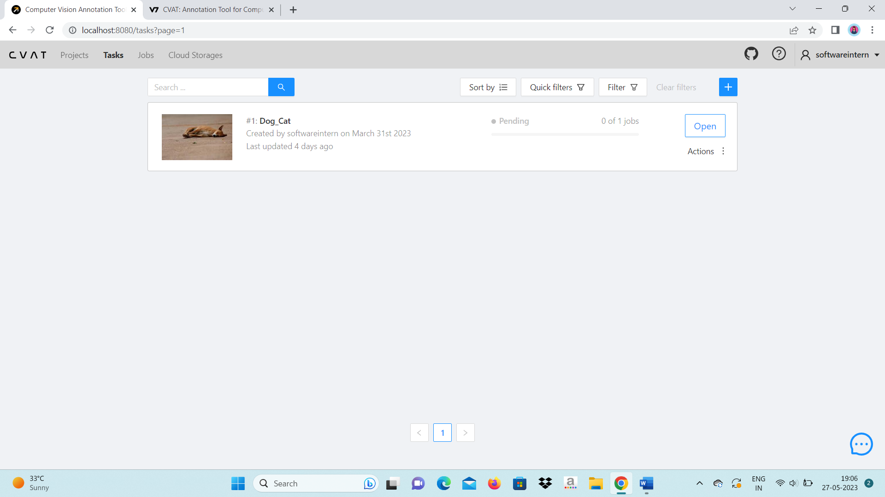

When you click on + sign you will get the same interface as early to create the task. Add labels and submit.

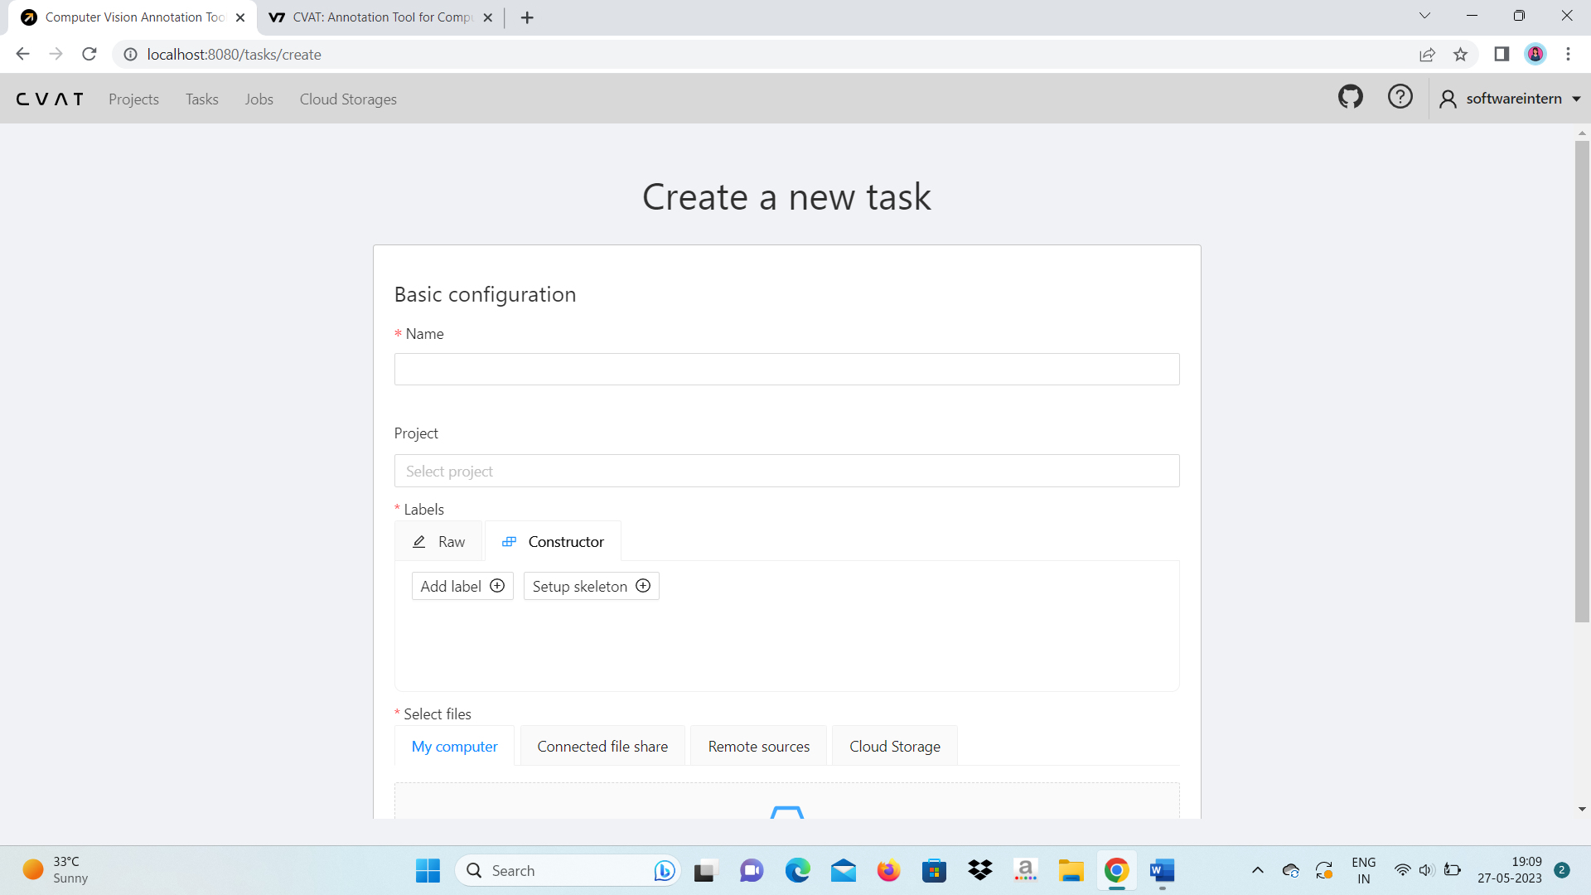

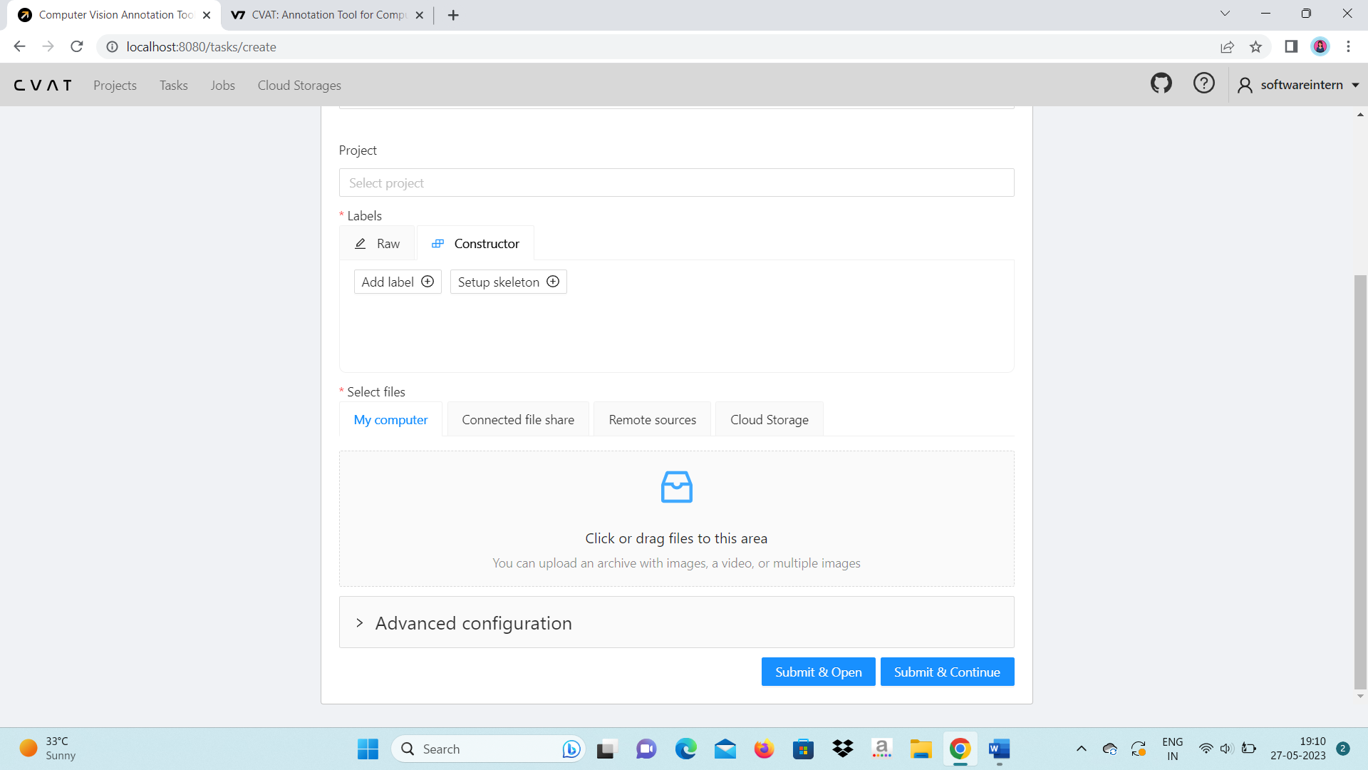

When you create the task you will get interface. Click on Job#1.

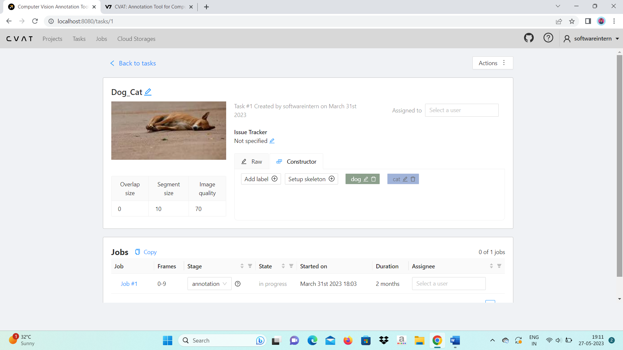

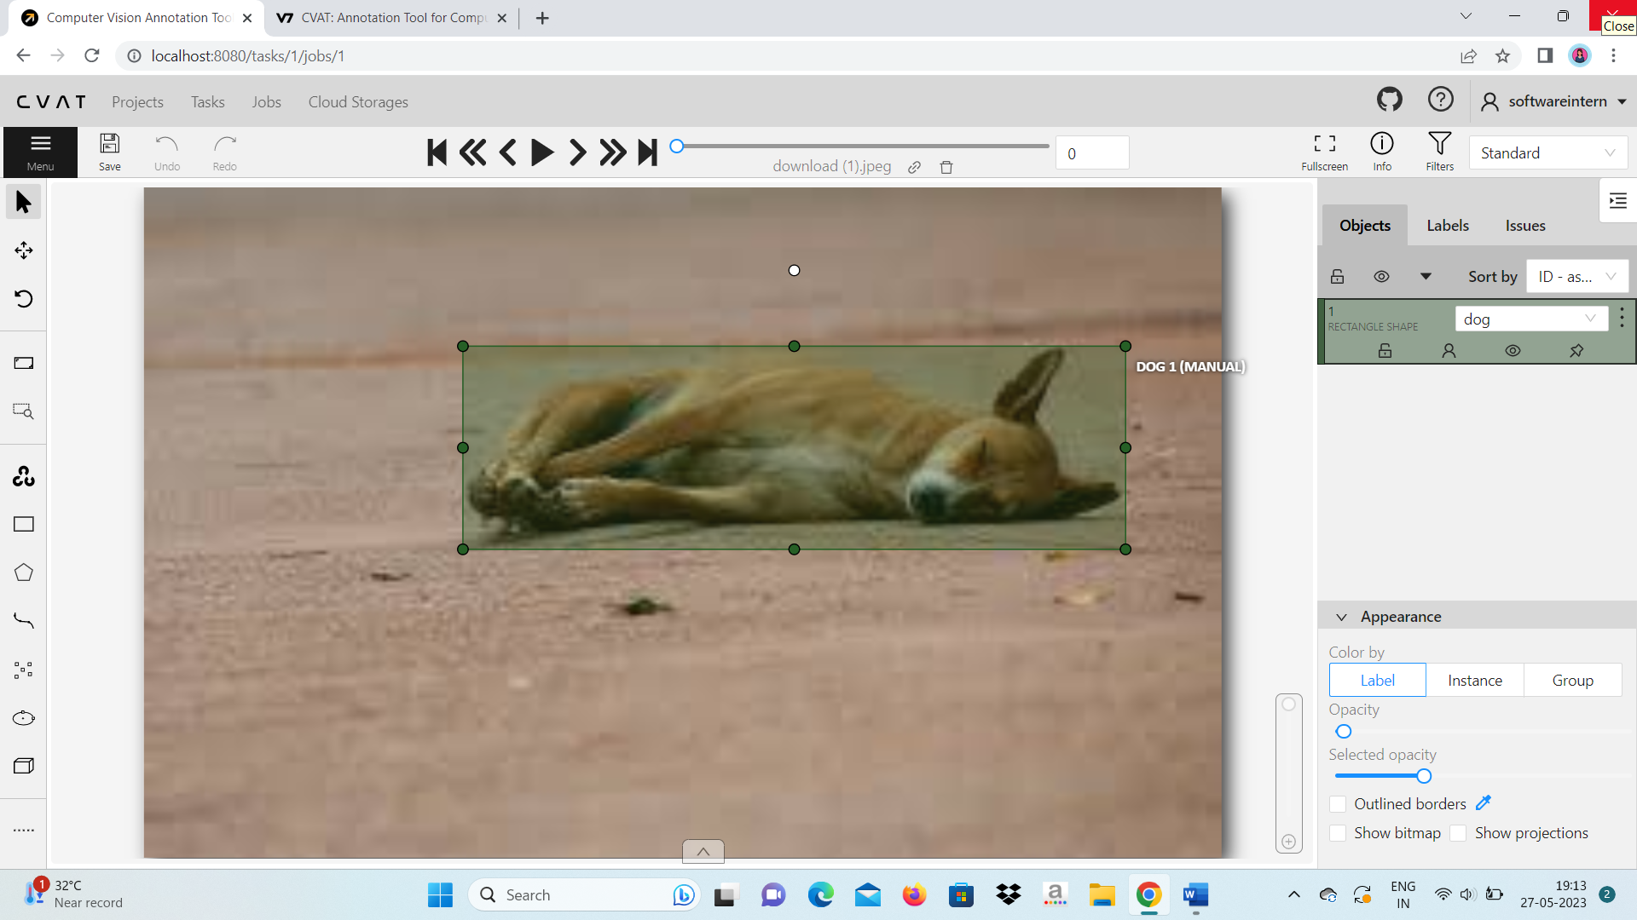

This will display frame /images you can change using arrows



You have to click on save continuously as CVAT cannot save your work automatically or change saving options in settings.

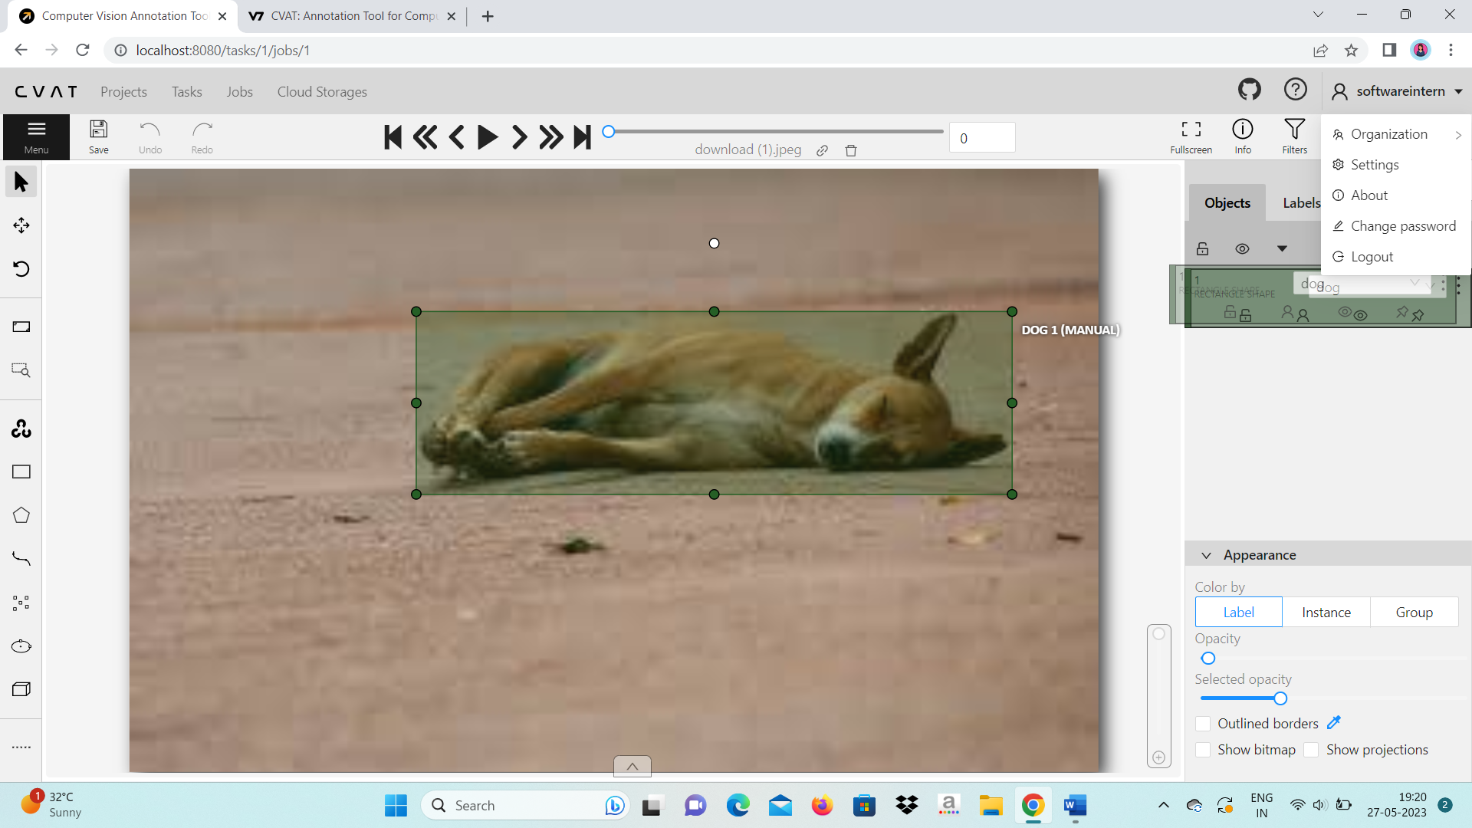

Click on your CVAT profile 🡪Settings.

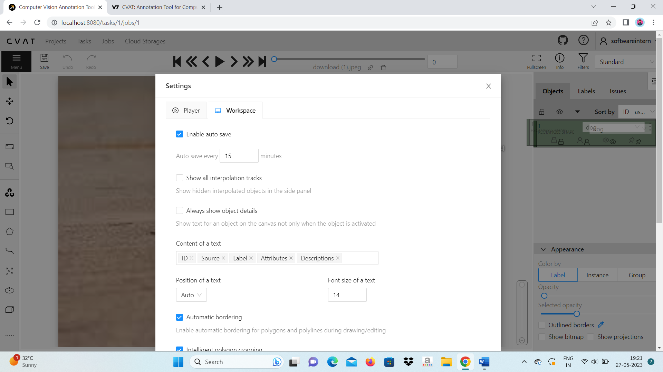

Click on workspace tab🡪enable auto save and Save your changes.

In menu tab you will get various options as shown. You can upload you annotations. Export your annotations when done with your completion of task.Remove your annotations. Open a new task or existing task.Change the Job state as per your choice to indicate as per your understanding. Or Finish the job when done.

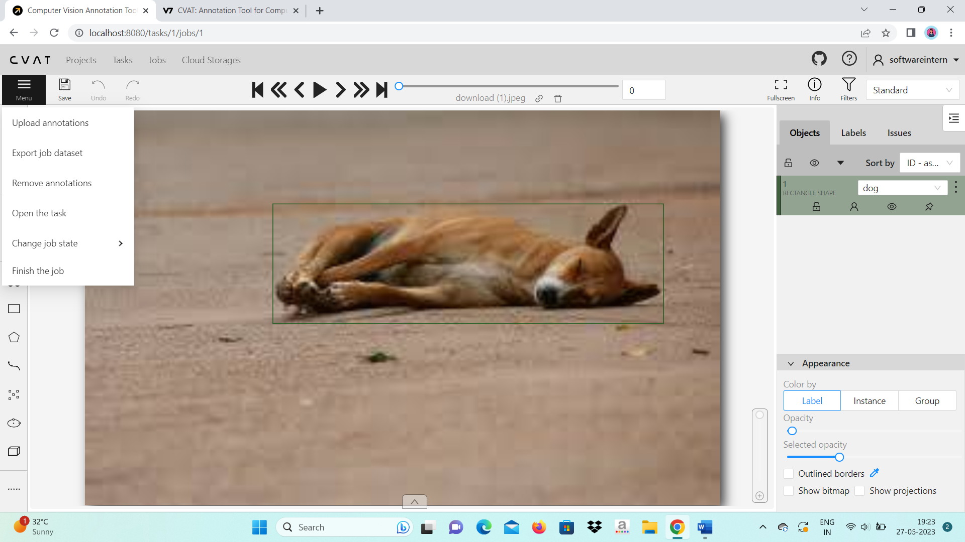

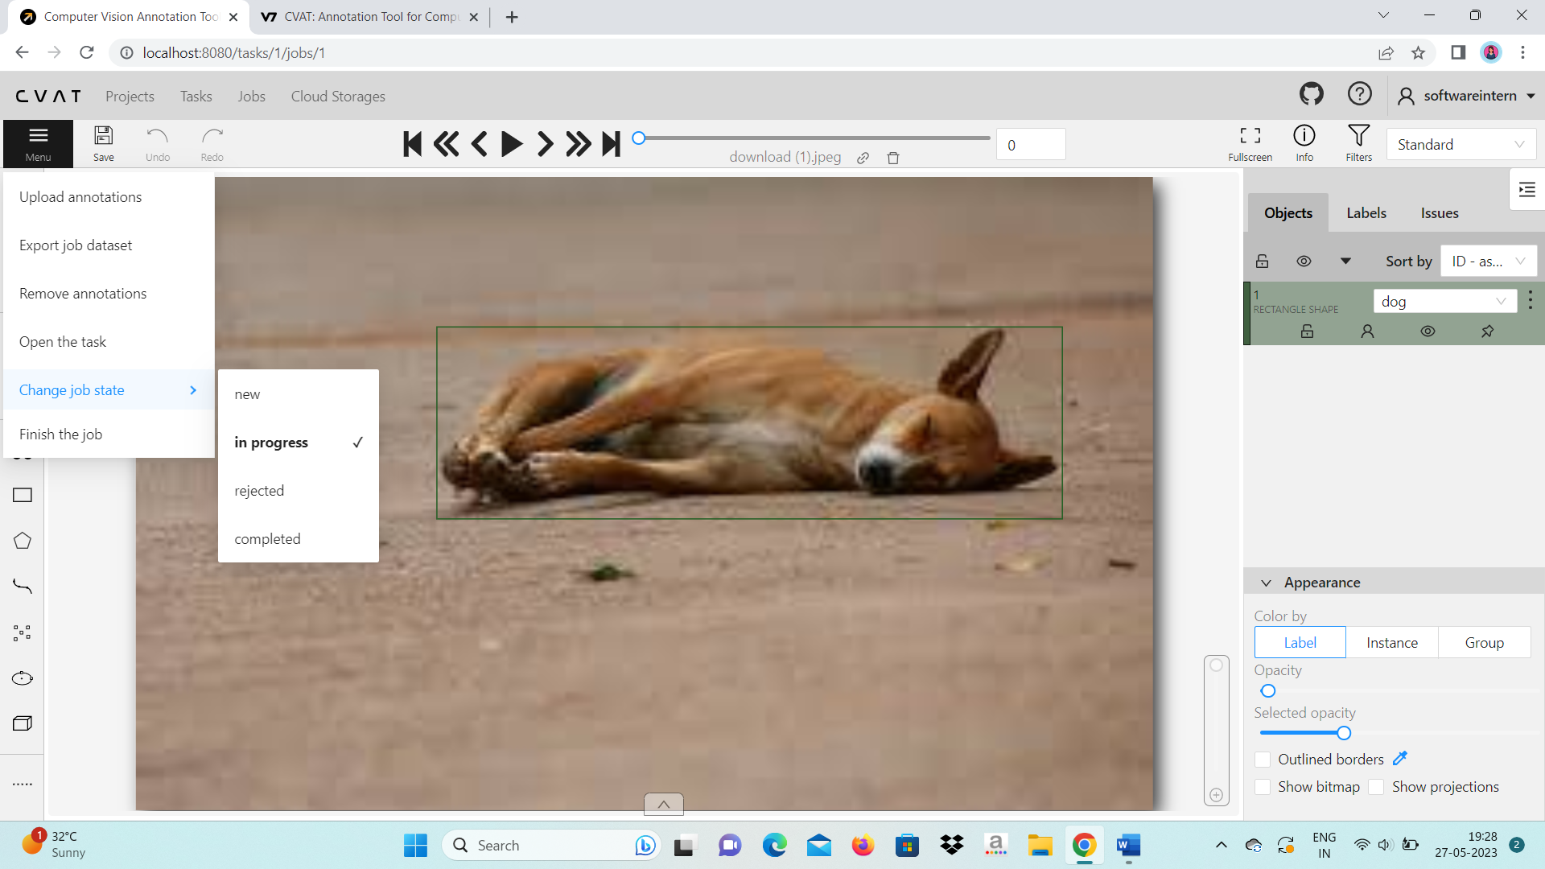



This option provides you plot points to an object like skeleton or very small object.

This option provides you to draw eclipse shape around your object then select the label then select on shape or track for a video.

This option provides you to annotate image / frame with cuboid shape then select the label then select on shape or track for a video.

This option provides you with cursor on image. (Shortcut: Press ESC key)

Select this option to select your region of interest it will display only that region or zoom that region.

Double click this option to fit your image/frame to you window size

This option provides you to rotate the image.( Shortcut:CTRL+SHIFT+R for anticlockwise,CTRL+R for clockwise)

This option provides you to move your image or frame.

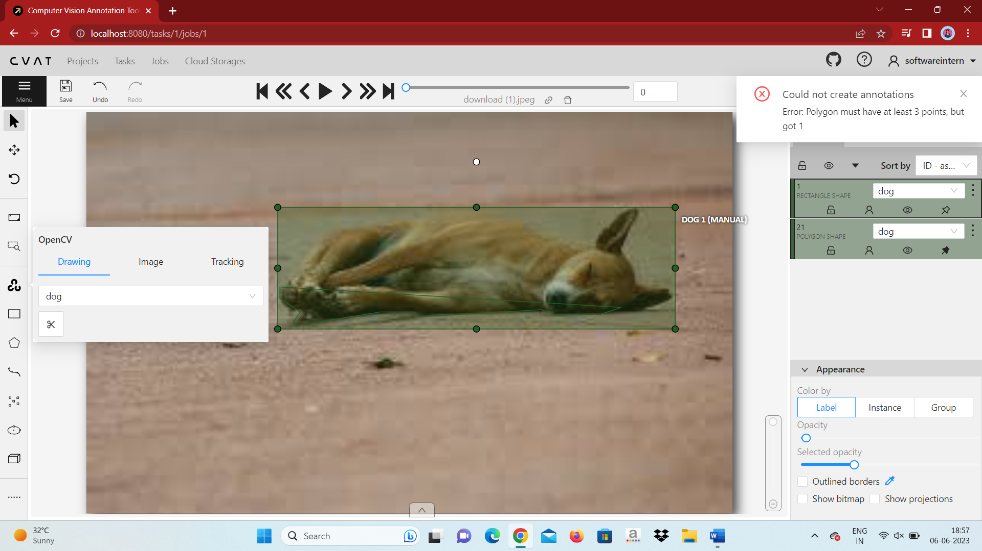

This option provides you more options to annotate.

This option provides you to draw lines around your object.

This option provides you to draw polygon around your object.

This option provides you to draw rectangle around your object.

It automatically draws the outline(polygon) to an object.

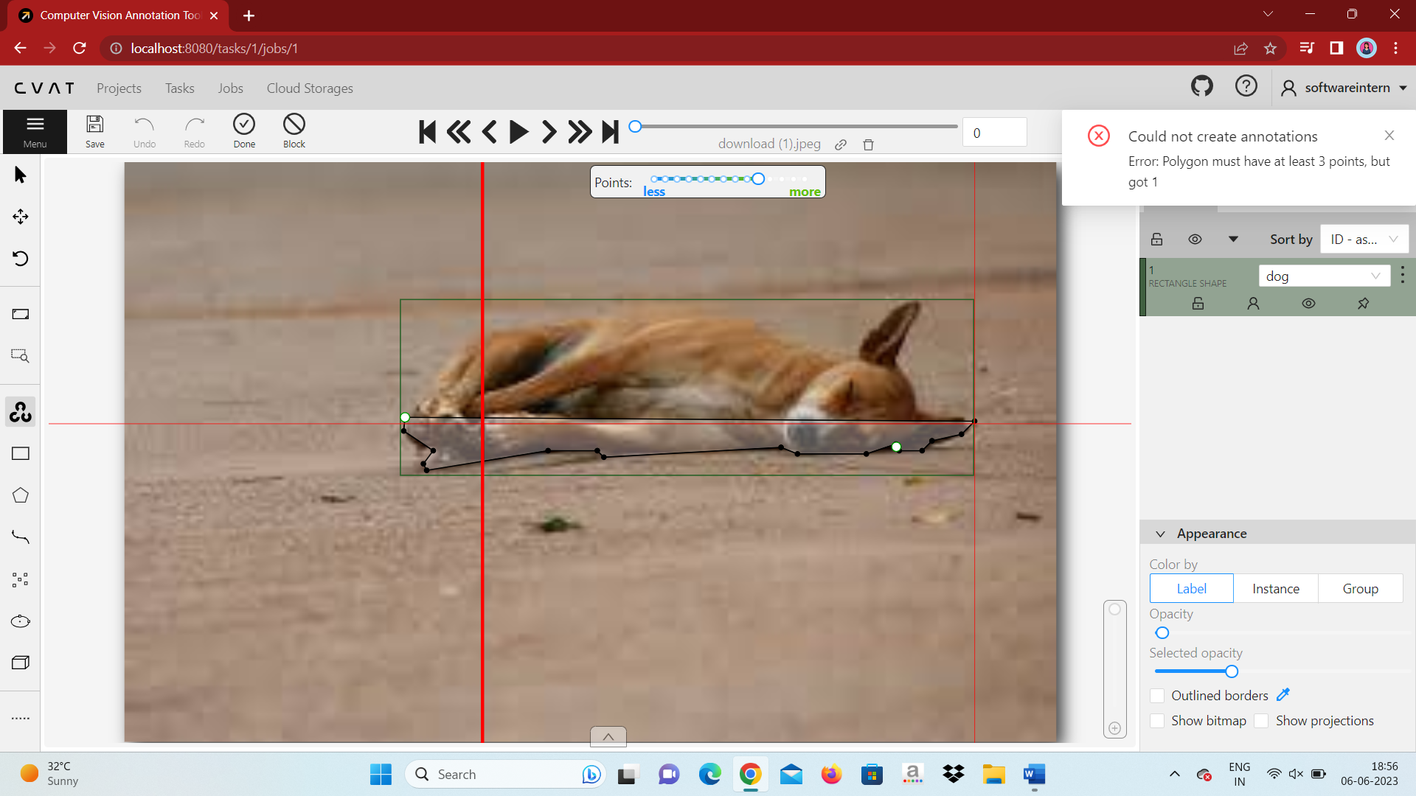

This is OpenCV option demo.

Whenever you have multiple objects to annotate you have to press SHIFT + N

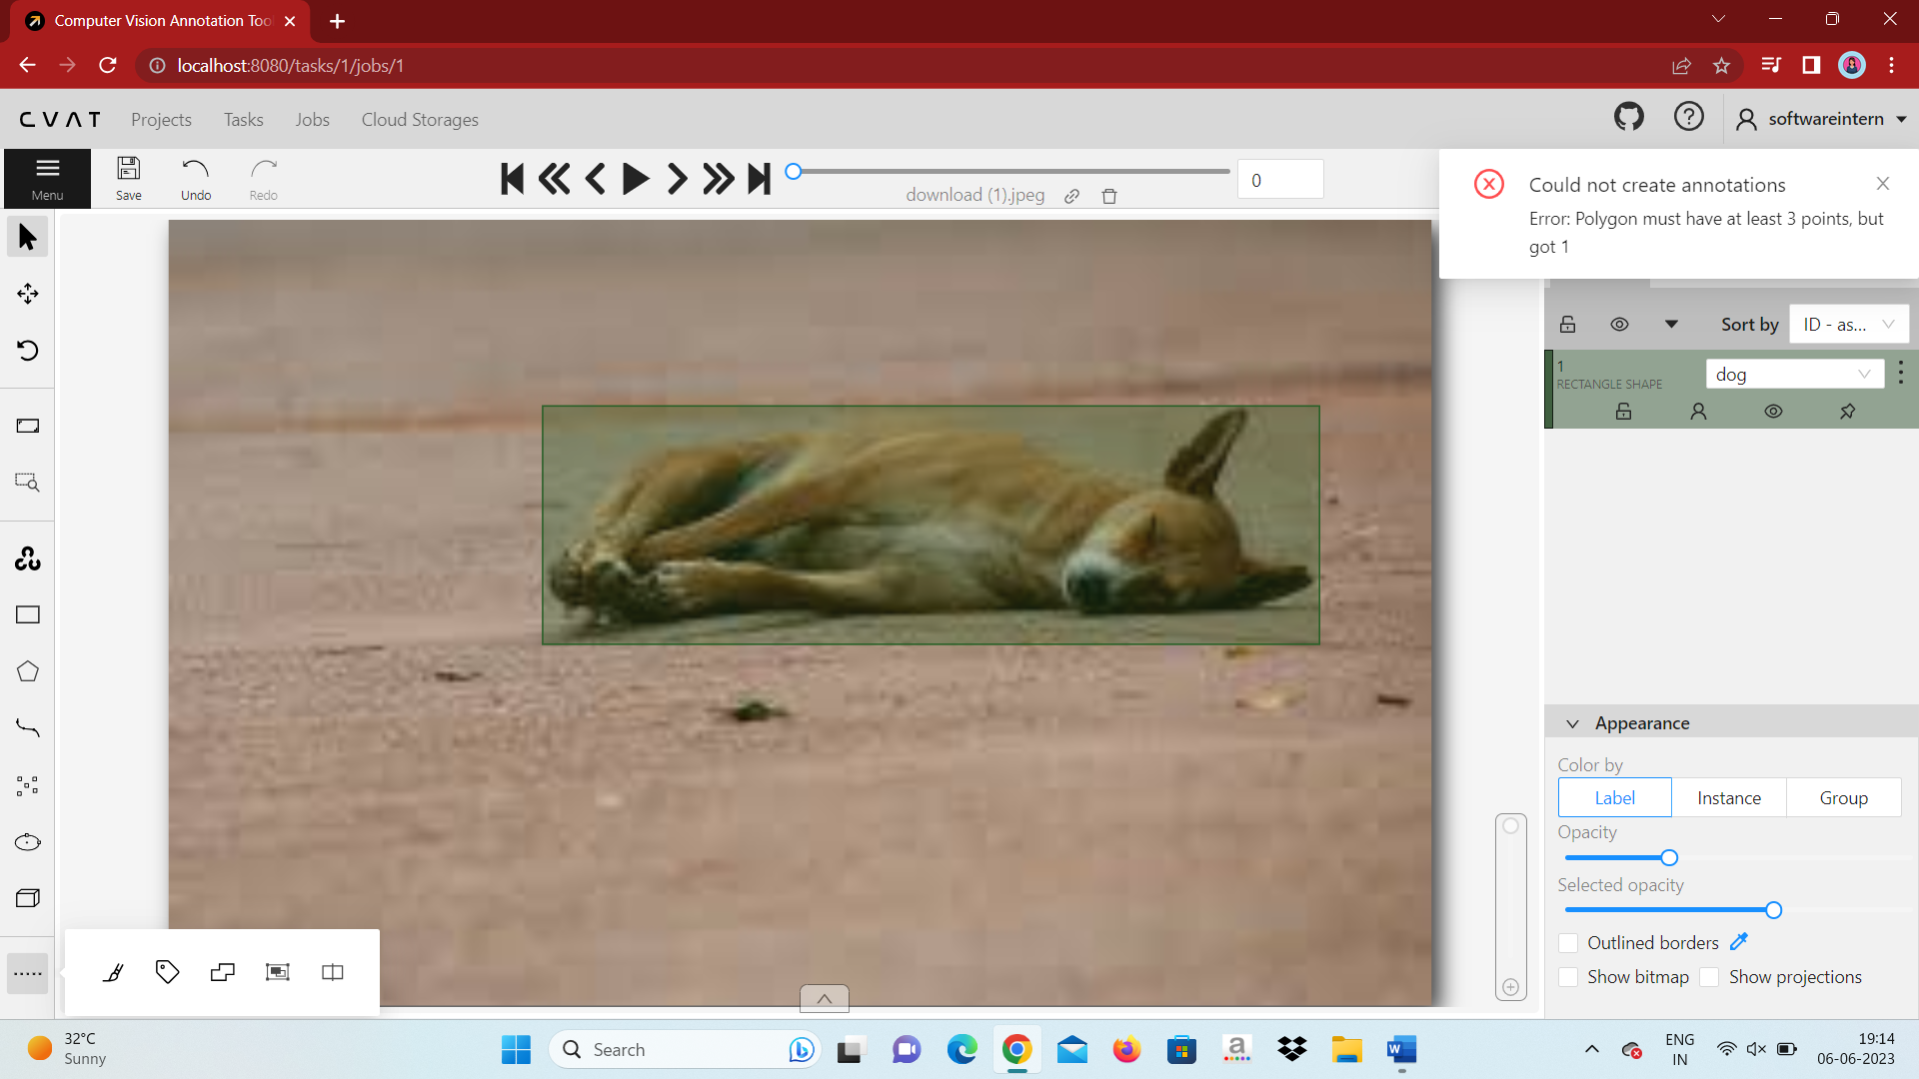

This option provides you split the track of the video.

This option provides you to merge your shapes around the object.

This option provides you tag around your object.

This option provides you to mask around object.

There are various formats to export you annotated object:

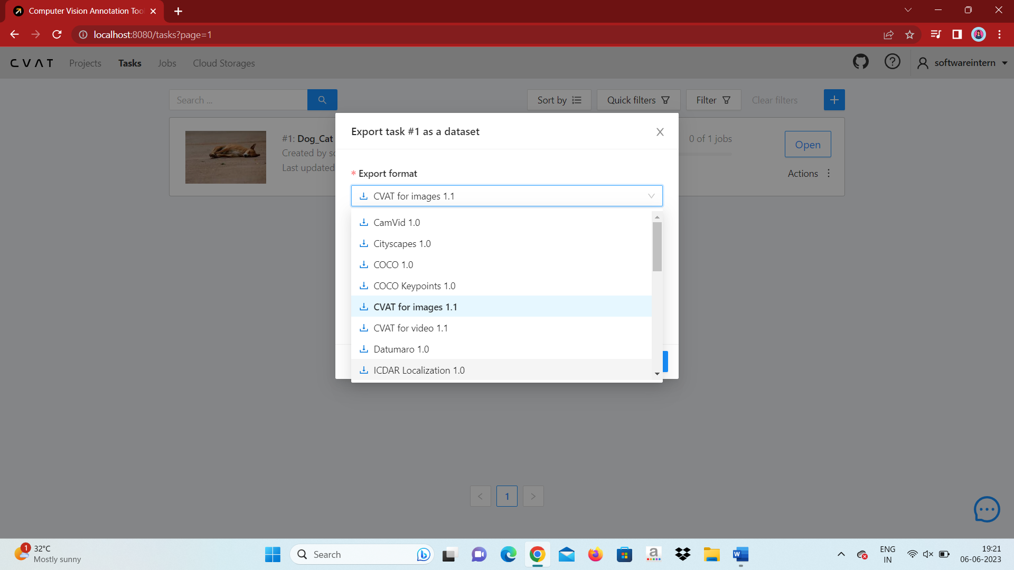

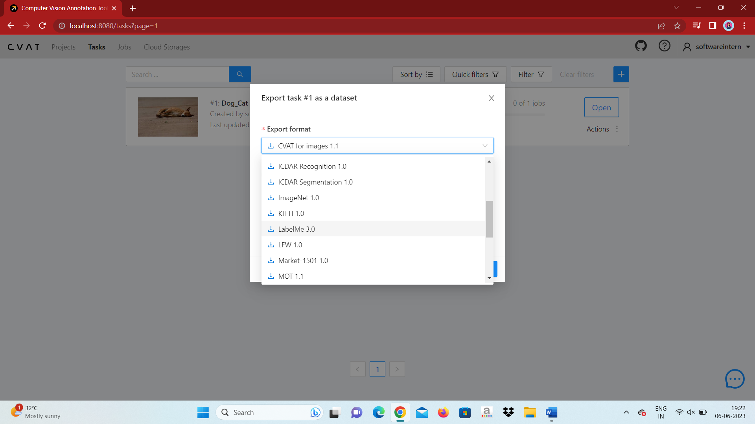

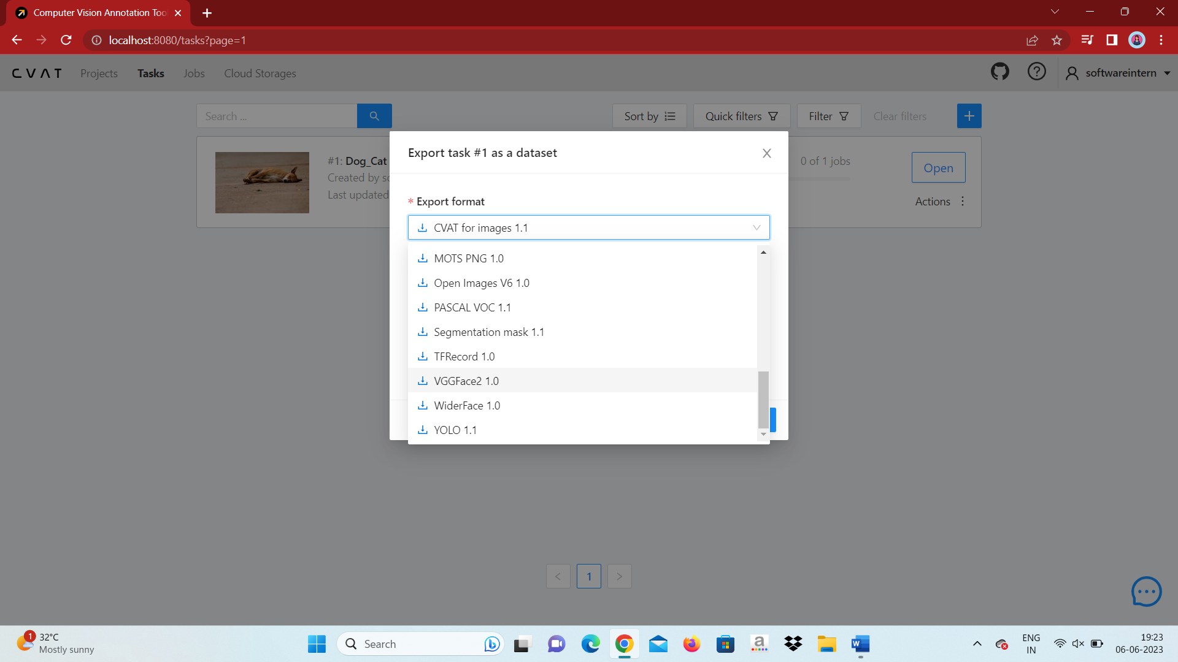

1. Pascal VOC: This format follows the annotation schema used in the Pascal VOC challenge. It exports annotations in XML files along with the corresponding image files.
2. COCO JSON: COCO (Common Objects in Context) is a widely used dataset format in computer vision. CVAT can export image annotations in the COCO JSON format, which includes information about the annotated objects, their categories, and the image metadata.
3. YOLO: YOLO (You Only Look Once) is a popular object detection framework. CVAT can export image annotations in YOLO format, which consists of text files with bounding box coordinates and class labels for each annotated object.